**LAb Activity 1**

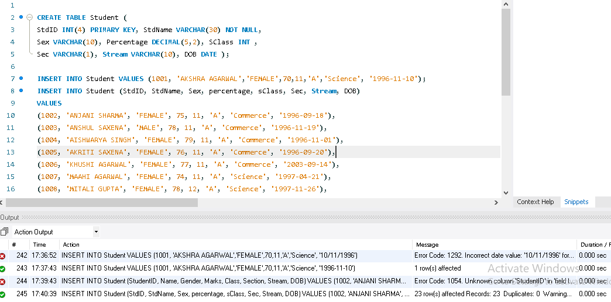

**Lab Activity 2:**

Open school database, then select student table and use following SQL statements.

TYPE THE STATEMENT, PRESS ENTER AND NOTE THE OUTPUT

1 To display all the records form STUDENT table.

SELECT * FROM student ;

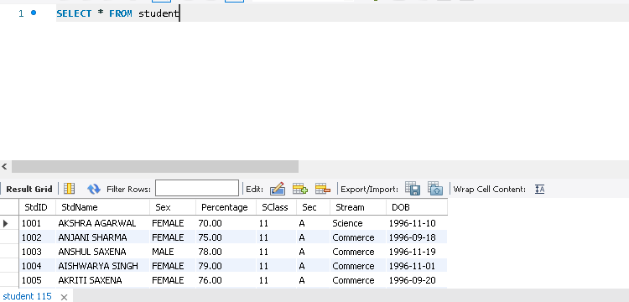

2. To display only name and date of birth from the table STUDENT.

SELECT StdName, DOB FROM student ;

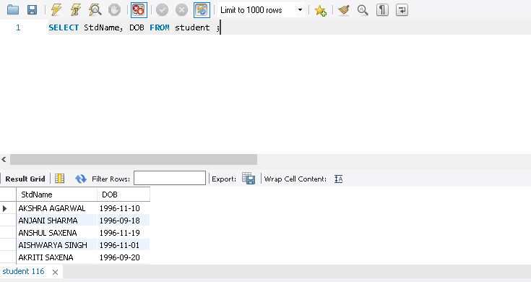

3. To display all students record where percentage is greater of equal to 80 FROM student table.

SELECT * FROM student WHERE percentage >= 80;

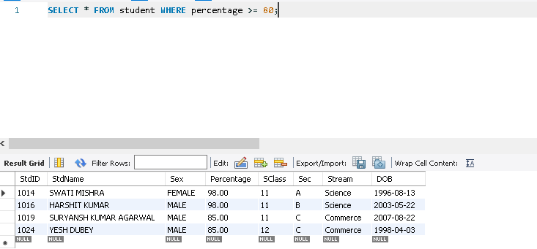

4. To display student name, stream and percentage where percentage of student is more than 80

SELECT StdName, Stream, Percentage from student WHERE percentage > 80;

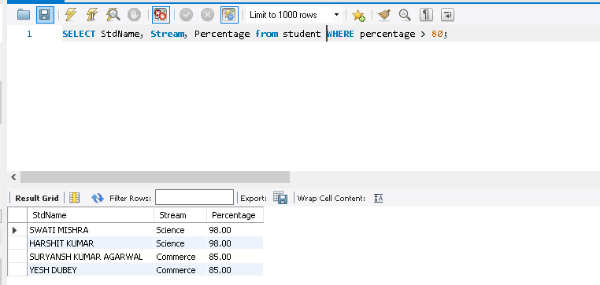

5. To display all records of science students whose percentage is more than 75 form student table.

SELECT * From student WHERE stream = ‘Science’ AND percentage > 75;

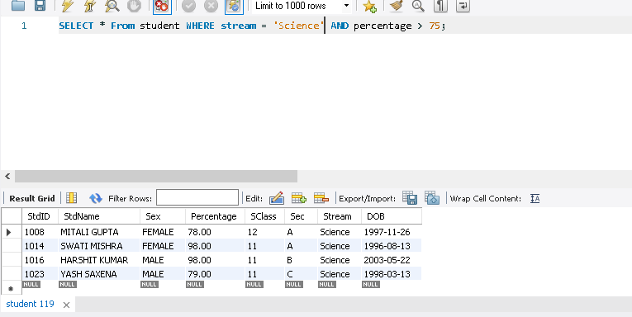

**Lab Activity 3:**

Open school database, then select student table and use following SQL statements.

TYPE THE STATEMENT, PRESS ENTER AND NOTE THE OUTPUT

1. To display the STUDENT table structure.

DESCRIBE Student;

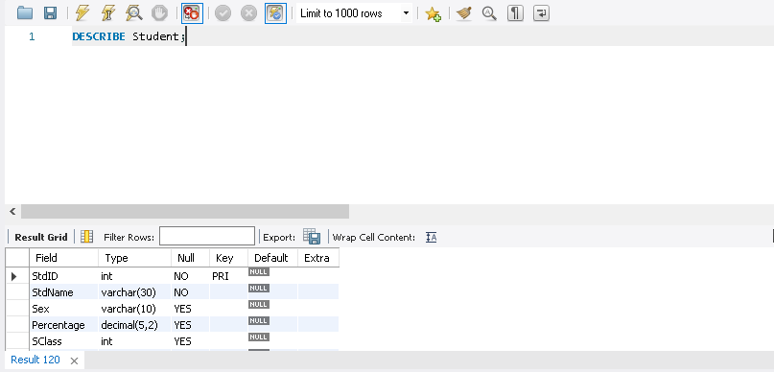

2. To add a column (FIELD)in the STUDENT table,for example TeacherID as VARCHAR(20);

ALTER TABLE Student ADD TeacherID VARCHAR(20);

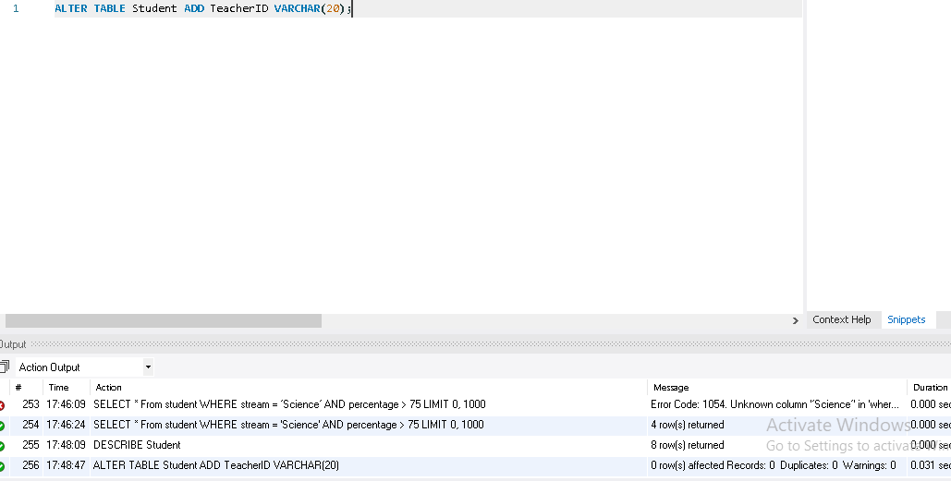

3. Type the statement

DESC Student;

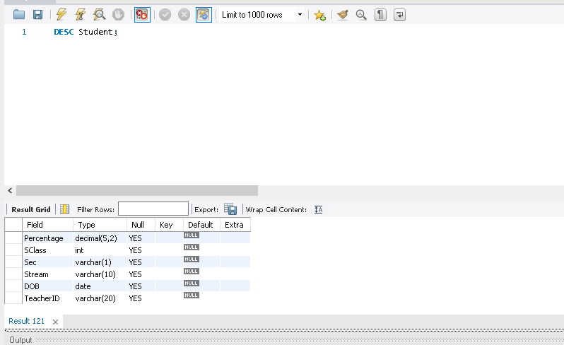

Press enter key, now note the difference in table structure.

4. Type the statement and press enter key, note the new field that you have added as TeacherID

SELECT * FROM student;

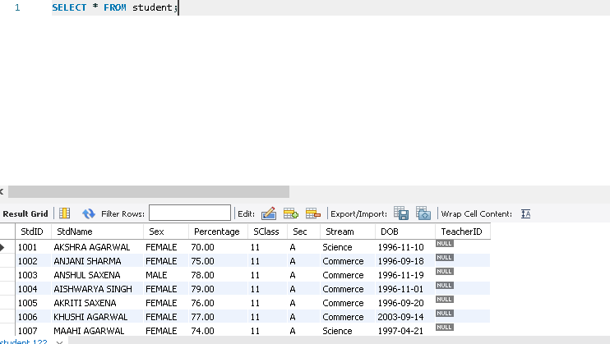

5. To modify the TeacherID data type form character to integer.

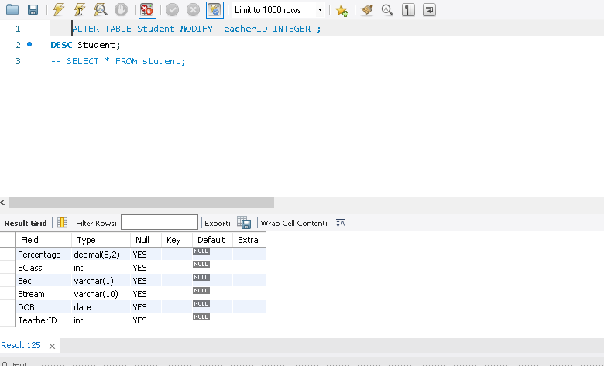

**Lab Activity 4**

1. To Drop (Delete) a field form a table. For e.g you wantto delete TeacherID field.

ALTER TABLE Student DROP TeacherID;

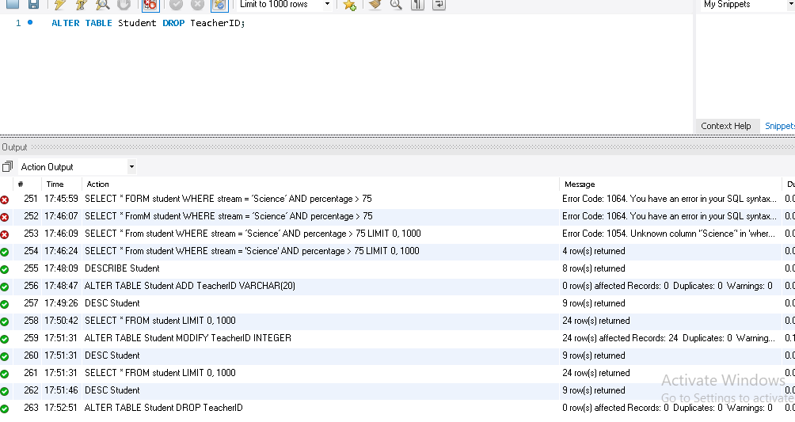

2. To subtract 5 form all students percentage and display name and percentage.

SELECT name, percentage - 5 FROM Student;

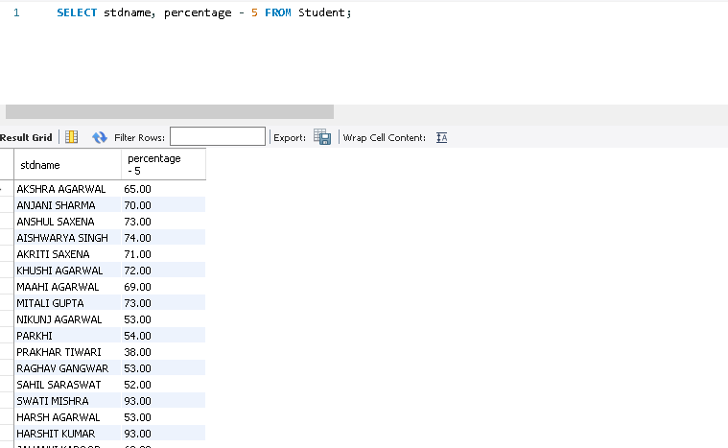

3. Using column alise for example we wantto display StdName as Student Name and DOB as Date of Birth

then the statement will be.

SELECT StdName AS "Student Name",

DOB As “Date of Birth” FROM Student;

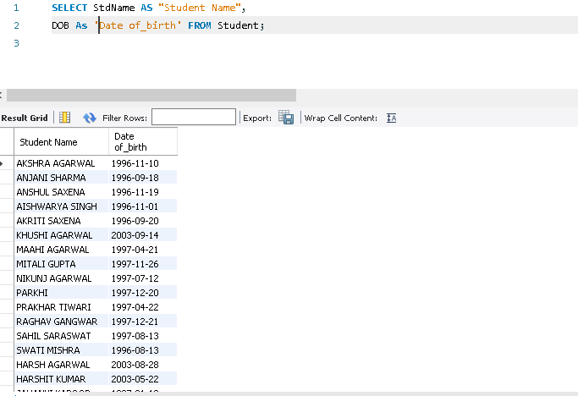

4. Display the name of all students whose stream is not Science

SELECT StdNameFROMstudent

WHERE Stream<>‘Science’;

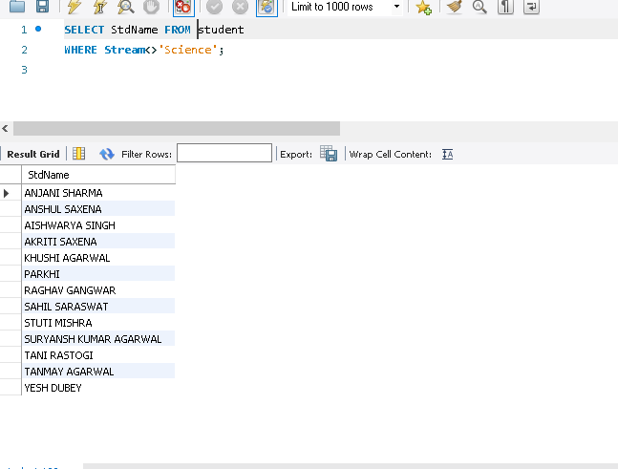

5. Display all name and percentage where percentage is between 60 and 80

SELECT StdName, percentage FROM student WHERE percentage >=60 AND

percentage<=80 ;

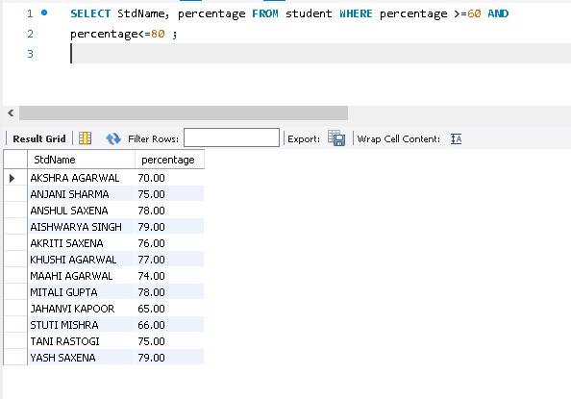

**Lab Activity 5:**

1. TochangeastudentnamefromSWATIMISHRAtoSWATIVERMAwhoseStdIDis1014andalsochange

percentage 86.

UPDATE Student SET StdName = ‘SWATI VERMA’, percentage = 86

WHERE StdId = 1014;

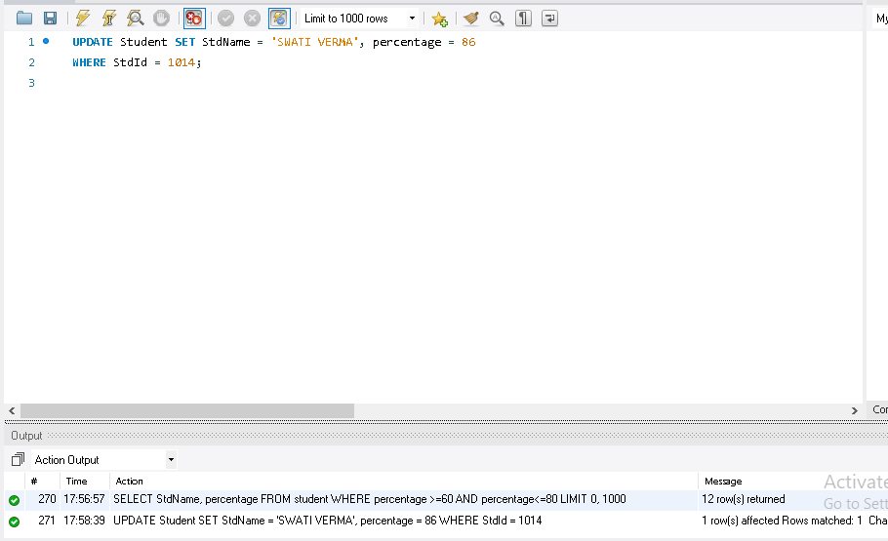

2. To delete the records form student table where StdId is 1016.

DELETE FROM Student WHERE StdID = 1016;

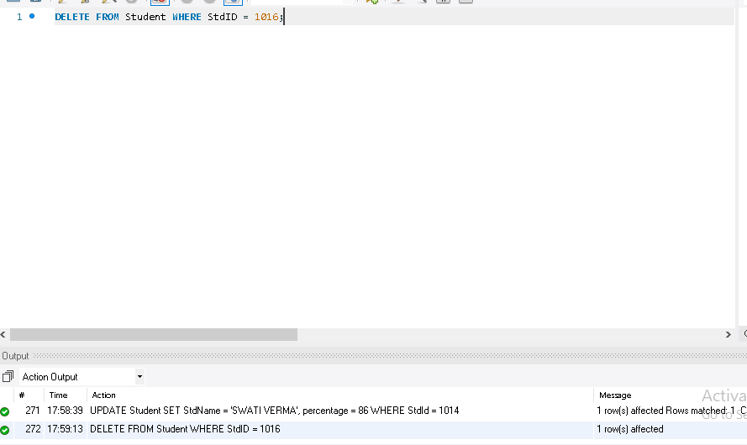

3. Type the following SQL statement and note the output.

SELECT * FROM Student WHERE StdName LIKE 'G_' ;

SELECT * FROM Student WHERE StdName='G';

SELECT * FROM Student WHERE StdName LIKE 'G%' ;

SELECT * WHERE Student WHERE StdName='%G%' ;

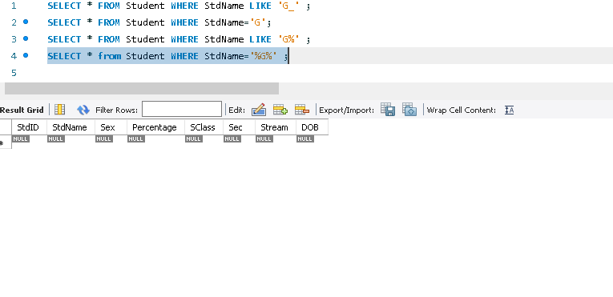

4. Display all the streams in student table.

SELECT DISTINCT Stream FROM Student;

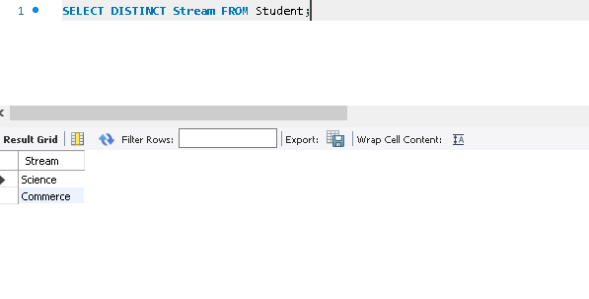

5. Note the output of the following statement.

SELECT StdName, Sex, Stream FROM Student WHERE percentage BETWEEN 70 AND 80;

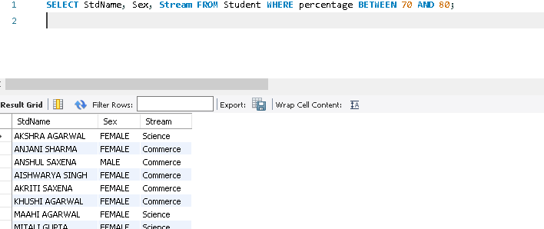

**Do yourself:**

**Create a Table Empl to store employee details as shown below and write statements**

**for following queries based on the table.**

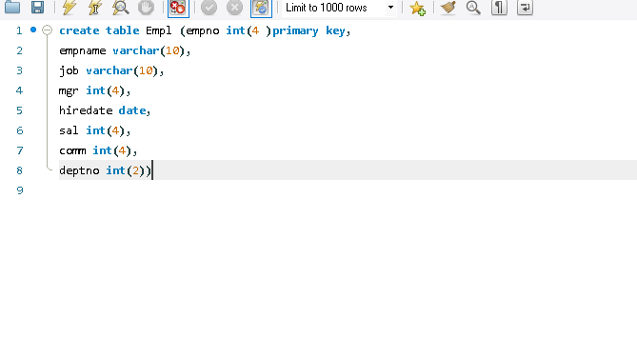

**1. Consider the Empl table and write SQL command to get the following.**

**a. Write a query to display EName and Sal of employees whose salary are greater than**

**or equal to 2200?**

Select empname,sal from Empl where sal>=2200

**b. Write a query to display details of employs who are not getting commission?**

Select empname from Empl where comm is null

**c. Write a query to display employee name and salary of those employees who don’t have**

**their salary in range of 2500 to 4000?**

Select empname,sal from Empl where sal between 2500 and 4000

**d. Write a query to display the name, job title and salary of employees who don’t have manager?**

Select empname,job,sal from Empl where mgr is null

**e. Write a query to display the name of employee whose name contains “A” as third alphabet?**

Select empname from empl where empname like ’__A%’

**f. Write a query to display the name of employee whose name contains “T” as last alphabet?**

Select empname from empl where empname like ’%T’

**g. Write a query to display the name of employee whose name contains ”M” as First and**

**“L” as third alphabet?**

Select empname from empl where empname like ’M_L%’

**h. Write a query to display details of employs with the text “Not given”, if commission is null?**

SELECT empname, COALESCE(comm, 'Not given') AS commission

FROM empl;